Exercise 4: Creating and Configuring a Maven Project

**Scenario:**

You need to set up a new Maven project for the library management application and add Spring dependencies.

**Step 1: Create a New Maven Project:**

Create a new Maven project named **LibraryManagement**.

The Following Configuration were used:

* **Project:** Maven (LibraryManagement4)
* **Language:** Java
* **Group:** com.library
* **Artifact:** LibraryManagement
* **Java Version:** 8

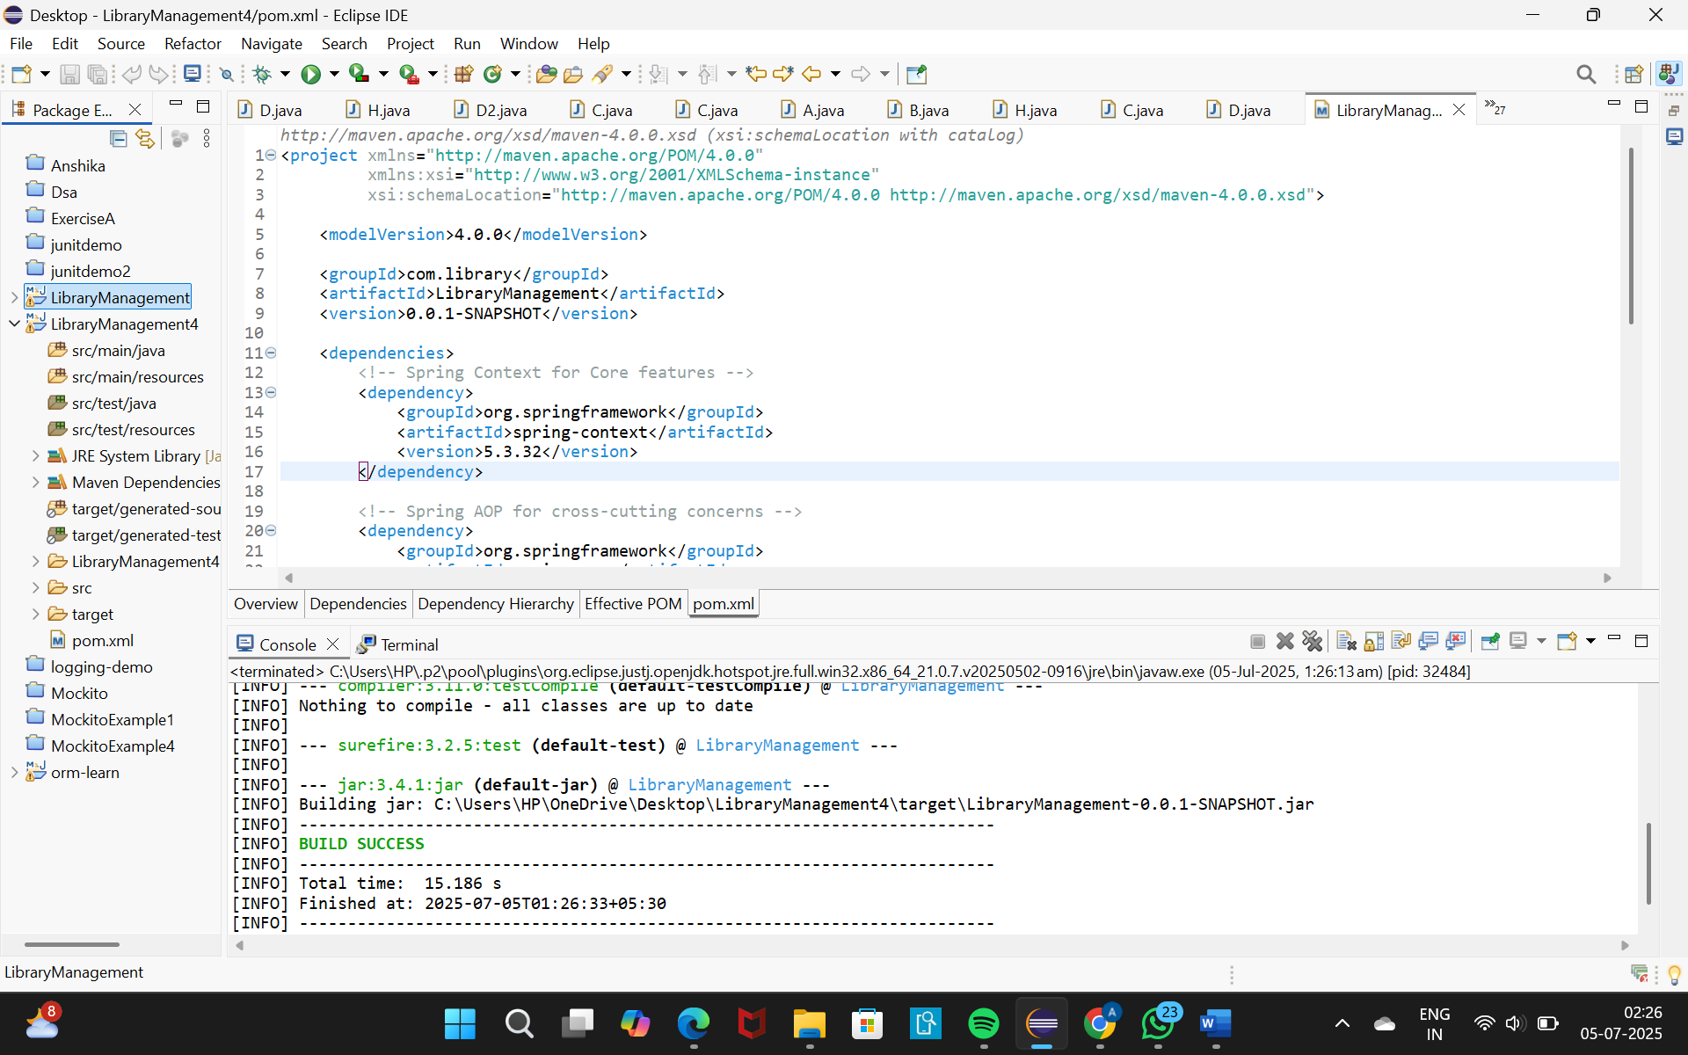

Build Success Screenshort

**Step 2: Add Spring Dependencies in pom.xml:**

The following Spring dependencies were included to support the required backend functionalities:

* **Spring Context**
* **Spring AOP**
* **WebMVC**

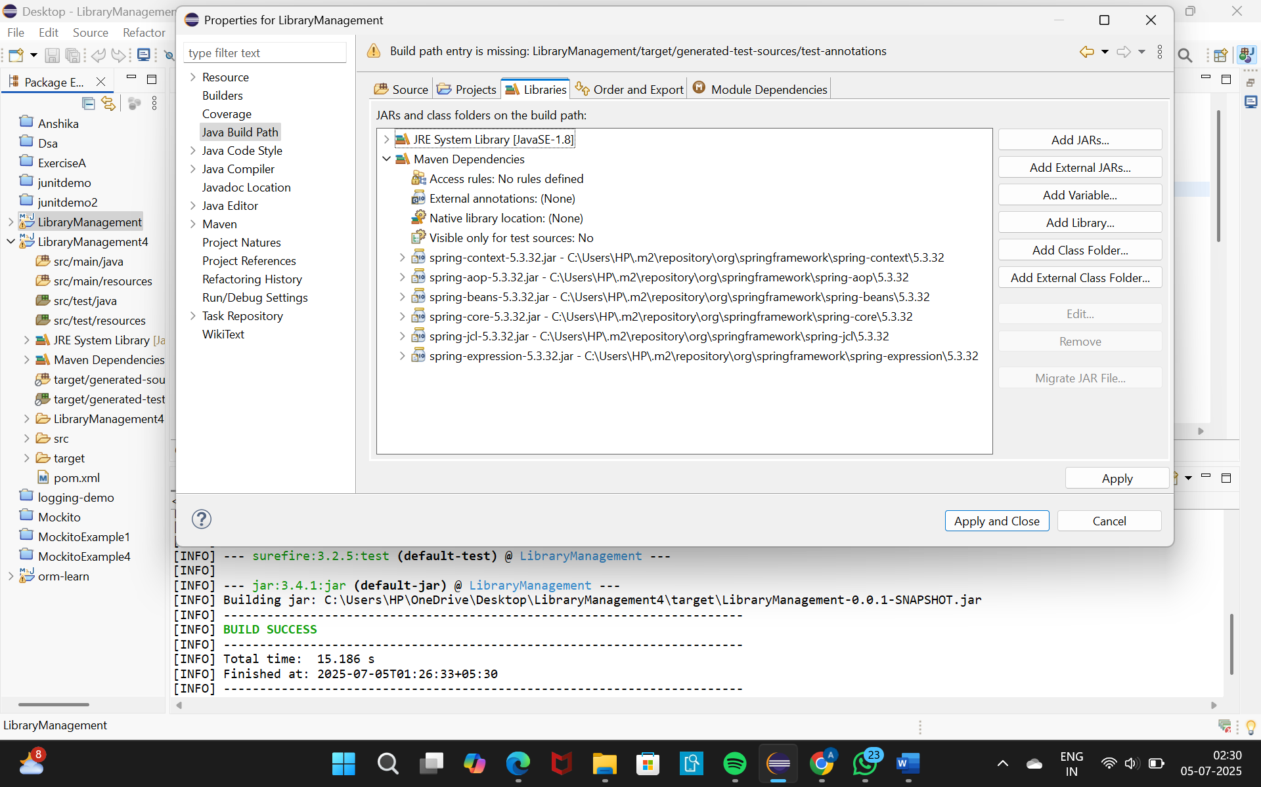

**Step 3: Configure Maven Plugins:**

To ensure compatibility with Java 1.8, The Maven Complier Plugin was added to the pom.xml with the following configuration:

